**California State University Long Beach**

**College of Engineering**

**Computer Engineering Computer Science Department**

**Tuesday, November 11, 2019**

**Sixfold Flat File ArchiveDesign Document V2.0**

**Group Members:**

**Michell Kuang (Team Lead) 013421094**

**Joshua McDaniel 014542786**

**Jingyan Du 014436615**

**Peter Park 002948398**

**Jacen Tan 012393782**

**Daniel Gione 016513144**

**Version History**

|  |  |  |  |
| --- | --- | --- | --- |
| **Version** | **Date** | **Author(s)** | **Comments** |
| V1.0 | 11/10/2019 | Jingyan Du | -Original document |
| v2.0 | 11/14/2019 | Jingyan Du | -Fix Diagram Mistakes  -Fix Concept Mistakes |
|  |  |  |  |

# Table of Contents

**Table of Contents** **2**

**Overview** **3**

**The Data Archive Process** **3**

**Timer Trigger** **4**

Possible Error 5

Timer Pass Due 5

**FileCollect** **5**

Possible Error 6

No File IOException 6

Argument Null Exception 6

**Flat File Output** **7**

Possible Error 7

File IOException 7

Copy Fail Exception 8

**File Delete** **8**

# Overview

This Document is made to show design concepts of data archive feature of SixFold Household Manager. To use storage space efficiently, archive systems for logs are necessary. Diagrams for data flowing and error handling will be included to guide the developers.

# The Data Archive Process

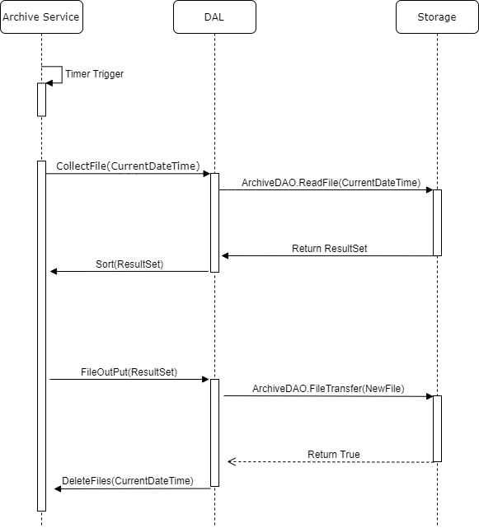

The Archive Service shall always run the timer to check the archive date. Once the time reached 00:00:00:00 UTC at the 1st of a month, the archive shall start, and the timer shall automatically set the datetime for next archive. The CollectFile shall be called with the current datetime, this function shall combine all logging flat files that were at least 30 days old into one flat file. Through the Data Access Layer, ArchiveDAO shall find all and add their contents into a result set and sort it. Then the FileOutPut function shall create a new flat file based on the result set. The new file shall be transfered to a separate storage machine by the ArchiveDAO. Once the transfer is finished, all archived files shall be deleted from the local storage.

# Timer Trigger

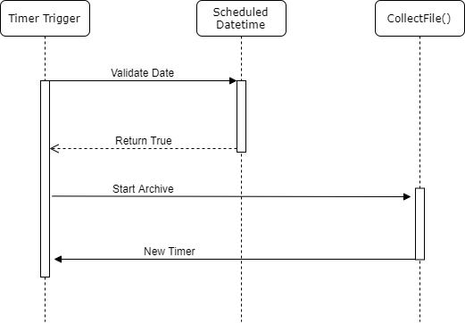

The time trigger is always running in the backend to check if the datetime reached the scheduled datetime, only if the current datetime is 00:00:00:00 UTC on the 1st of the month, the timer trigger shall set a new timer for next archive and start the archive. The time trigger should be async.

## Possible Error

### Timer Pass Due

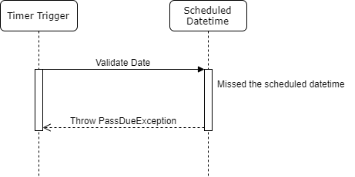

For any reason if the timer trigger passed the scheduled datetime, the archive should not start. A PassDueException shall be thrown, the error shall be logged and the system admin shall be notified. The timer shall be set to the next datetime for archive and this archive shall be logged as failure.

# FileCollect

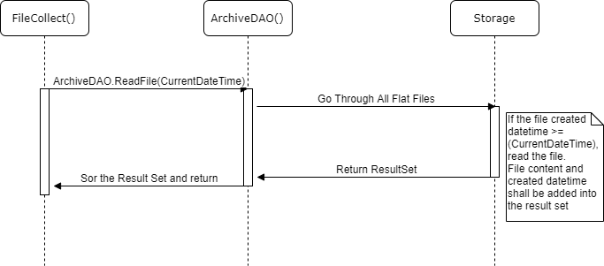

The FileCollect function shall collect all eligible flat files into one result set. The ArchiveDAO shall go check all log flat files in the local storage, only for files created in the eligible range shall be read and their contents could be added into the result set with their created datetime.

## Possible Error

### No File IOException

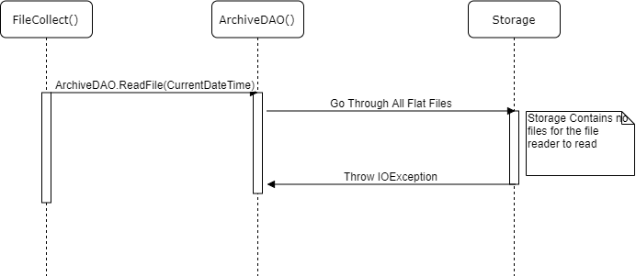

If the local storage contains no log flat file, the the file reader cannot any files. The archive process shall be stopped. An IOException shall be thrown and the system admin shall be notified. This archive shall be logged as a failure.

### Argument Null Exception

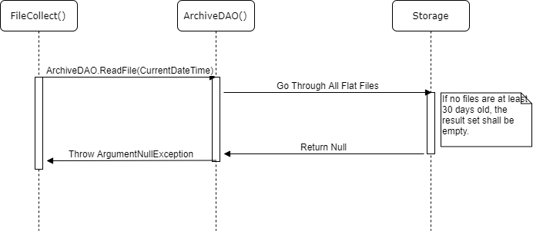

If the FileCollect function received a null, it means no flat files were at least 30 days old and the resultset is empty. The archive process shall be stopped, an ArgumentNullException shall be thrown, the system admin shall be notified and this archive process shall be logged as failure.

# Flat File Output

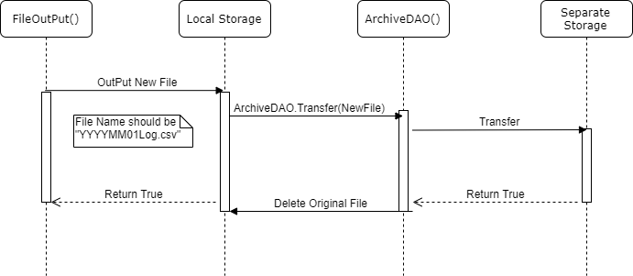

The FileOutPut function shall output the result set as a new flat file to the local storage. The DAO shall call transfer function to transfer this flat file to the separate storage, and once the transfer is finished, the flat file on local storage shall be deleted to save space.

## Possible Error

### File IOException

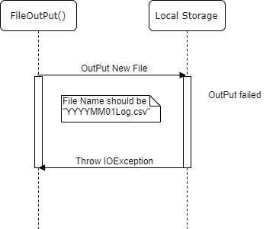

If the file output is failed, an IOException shall be thrown. The system shall retry to create .csv file after logging the error for no more than 3 times. If the file output is still failed, the process of data archive should be stopped, the archive should be logged as failure, and the system admin shall be notified.

### Copy Fail Exception

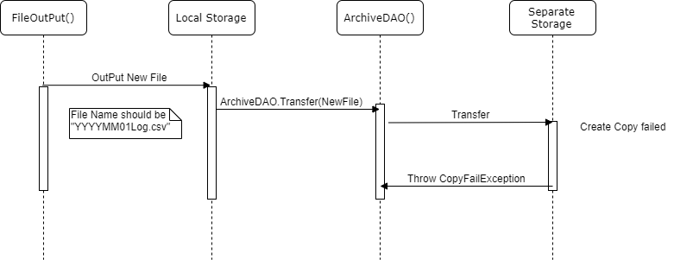

If the system failed to create copy on the separate storage for the flat file, a CopyFailException shall be thrown, the error shall be logged and system should retry the copy no more than 3 times. If it still failed, the archive process should be stopped, the archive should be logged as failed and the admin should be notified.

# File Delete

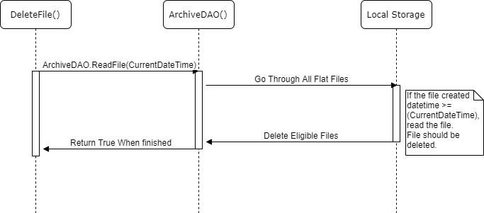

Once all archive steps were finished, this function shall be called to clean up all archived log flat files, the DAO shall go through the local storage again and delete all eligible files with the same condition as archive.